 

**Placement Empowerment Program**

**Cloud Computing and DevOps Centre**

Automate File Copying with a Script : Create a script to copy files from one folder to another automatically.

Name: Aksha S Department: CSE

**Introduction**

Automating file copying is essential for backup, synchronization, and data management tasks. By using scripting, you can automate the process of transferring files from one folder to another without manual intervention.

In this POC, we will create a script that copies files from a source folder to a destination folder automatically. This script will ensure files are always backed up or moved as needed.

**Overview**

Automating file copying is a crucial task in system administration, backups, and data management. This POC focuses on creating a script that automatically transfers files from one folder to another, reducing manual effort and ensuring data is consistently backed up or synchronized. The automation can be scheduled to run at specific intervals, making it an efficient and reliable solution for file management.

**Objectives**

By the end of this POC, you will:

1. **Understand File Copying Automation** – Learn how to automate file transfers using scripting.
2. **Write a Batch Script** – Create a script to copy files from a source folder to a destination folder.
3. **Execute the Script Manually** – Run the script to verify successful file copying.
4. **Automate the Process** – Schedule the script using Windows Task Scheduler for automatic execution.
5. **Ensure Data Safety** – Maintain an up-to-date backup of important files without manual intervention.

**Importance**

**✅ Efficiency & Time-Saving**

Automates the repetitive task of file copying, eliminating the need for manual intervention.

**🔄 Data Backup & Recovery**

Ensures that important files are consistently backed up, preventing data loss in case of accidental deletion or system failures.

**📌 Error Reduction**

Minimizes human errors associated with manual file transfers.

**🔧 Scalability & Automation**

Once implemented, the script can handle large-scale file transfers and be scheduled for periodic execution.

**🔗 Integration with Other Systems**

Can be extended for syncing data across multiple systems, making it useful for business workflows, development environments, and server maintenance.

**Step-by-Step Overview**

**Step 1: Define Source and Destination Folders**

Before writing the script, decide which folder contains the files you want to copy (source) and where they should be copied to (destination).

For example:

* **Source Folder:** C:\Users\Bhavadharani.S\Documents\Source
* **Destination**
* **Folder:** C:\Users\Bhavadharani.S\Documents\Backup

Ensure these folders exist. If not, create them manually.



**Step 2: Create a Batch Script (copy_script.bat)**

A batch script can be used to copy files automatically.

1. Open **Notepad** and paste the following script:
2. **Save the file as** copy_script.bat (Make sure to select **"All Files"** in the "Save as type" field).

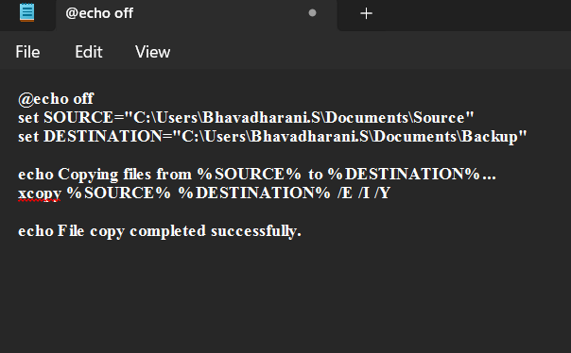

Step 3:

1. Open **Command Prompt** (cmd).
2. Navigate to the location of the script using:

***cd C:\Users\Bhavadharani.S\Documents***

1. Run the script by typing:

***copy_script.bat***

If successful, all files from Source should now be in the Backup folder.

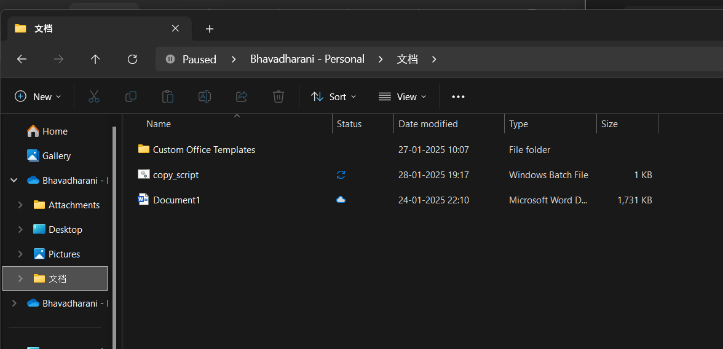

Step 4**:**

**Automate the Script using Task Scheduler**

To automate this process, schedule it to run daily.

**1. Open Task Scheduler**

* Press Win + S and search for **Task Scheduler**.
* Click **Create Basic Task**.

**2. Configure the Task**

* **Name:** File Copy Automation
* **Trigger:** Select **Daily** and choose a time.
* **Action:** Choose **Start a Program**.
* **Program/script:** Browse and select copy_script.bat.
* Click **Finish** to save.

Step 5

**Verify Automation**

1. Wait until the scheduled time.
2. Check the Backup folder to ensure files were copied.
3. Optionally, check Task Scheduler's **History** tab for execution logs.

